**A few recommendations for “OKEY Bank”**

**on effective practical AI implementations**

**Current Task**

Let’s imagine that the financial company “OKEY Bank” requested an independent analysis on the potential benefits of widely applying Artificial Intelligence technologies to the business. On our part, we are glad to provide the information on how AI can increase return on investment for the bank, what types of data will be necessary for the algorithms processing, and why business should be ready to prevent certain harmful side effects on society, while using such technologies.

**About the Bank**

“OKEY Bank” is a new digital-only financial institution with a brand application. The company has no standard public office space, primarily providing virtual service, supported by SaaS Management Platform. Wen (2013) described the Software-as-a-Service as a model that allows customers to use an app running on a cloud infrastructure. A customer is able to open a bank account via application on the computer browser or smartphone, for example. The courier will deliver a physical bank card and Customer Agreement to any specified space, whether it is a house or an office. This format became more common during the pandemic. Every day “OKEY Bank” issues 2 thousand cards, having more than $600 thousand in assets. Let’s assume, the bank has about 1 million customers at this moment in total and it is ready to double this figure in the next year. It could not have been done without the assistance of AI or Machine Learning (ML) as a huge part of Artificial Intelligence. ­­

**Three Key Areas for AI in the Bank**

AI in banking applications is not limited to retail banking services only. Machine learning techniques gain popularity in the financial area, especially in banking, because of a variety of solutions to solve increasingly complex issues. Moreover, smart systems help to raise profits. In 2018 chairman of the Board of Russian Sberbank German Gref noted that in 2017 the bank gained additional $2–3 billion due to applying AI technologies. For comparison, the Sberbank’s net profit reached $11,6 billion on the same year (Salmanov, 2018).

Liu (2020) named Artificial Intelligence a “game-changer in transforming and digitalising modern businesses”. According to research in 2020 approximately $11 billion were invested in AI, and the financial sector is the largest contribution to AI.

Digalaki (2022) covers three main channels for using Artificial Intelligence by banks: a **Front office**, represented by conversational banking, **Middle office** with fraud detection and risk management and **Back office** submitted by Underwriting (are presented in Illustration 1). We offer to consider a couple of examples from each of the channels of AI in banking listed above.

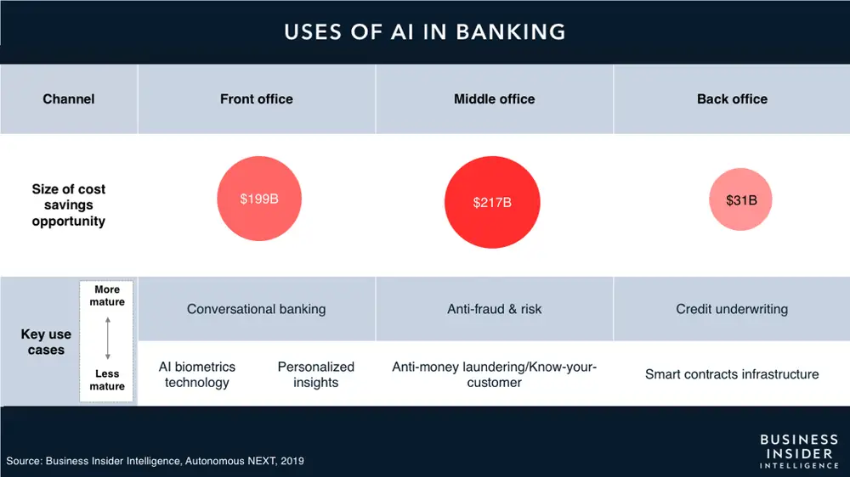

*Illustration 1. Uses of AI in Banking. Business Insider Intelligence, 2019.*

**AI powered chatbots (Front office)**

Chatbot service aims to give better customer engagement. According to Crosman (2018) the virtual assistants provide 24/7 services to the customer. On the one hand, it helps banks improve operational efficiency and speed by handling a large number of inquiries simultaneously. On the other hand, there may be certain reputational risks. For instance, Microsoft’s Tay in 2016 started to send racist nonsense to customers on Twitter. The problem was the bot started mimicking her followers, which is not an appropriate idea for the bank service. If a mistake was made by a human, they may apologize and win the confidence of consumers back. One slip from AI – and the business image is tainted badly.

In fact, AI-enabled chatbots are able to provide customers with needed information. These smart digital assistants can help support customers if call centers are overwhelmed (e.g., as we observed during COVID-19 pandemic).

[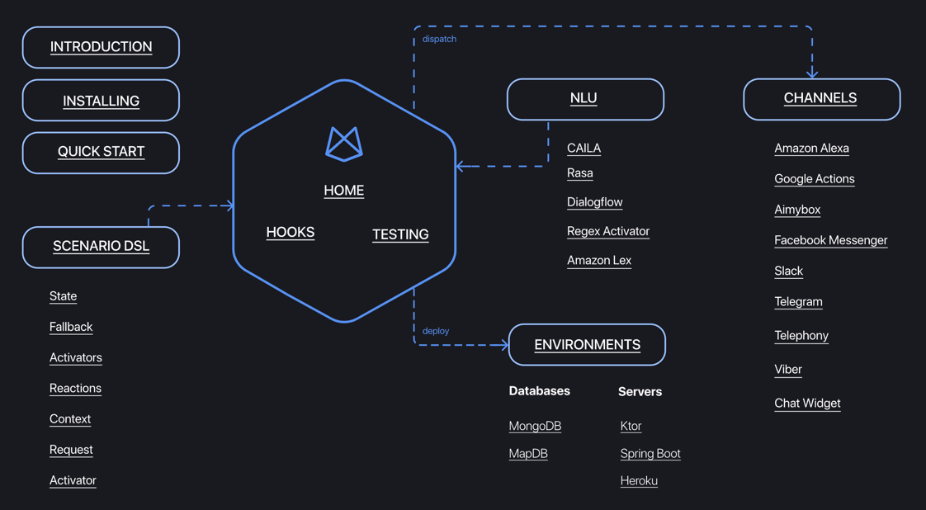](https://just-ai.com/en/jaicf)There are several ways to apply chatbots for “OKEY Bank”. For the start we recommend using a third-part assistance. It would be Just AI Conversational Framework with open-source Kotlin based chatbot and voice assistant development, which is free of charge for commercial use. The lifecycle is presented on JAICF website.

*Illustration 2. Available from: https://just-ai.com/en/jaicf*

The other option is to create a bank’s own chatbot. Khavya (2018) in the article “Banking Bot” mentioned that the front end presumably may be designed with Recast.AI framework, where all the bot tools are integrated. Also, the system uses NLP, and Machine Learning. A chatbot may be integrated with a website which is coded in PHP and has a MYSQL database management system. Just a few samples of chatbot implementations in banking: **Erica** by Bank of America with 19.5 million users in 2021 (+7.3 million y-o-y) (Schwartz, 2021); **Ally Assist** by Ally Bank, **Amy** by Hong Kong HSBC; **Ceba** by Australian Commonwealth Bank, etc.

Przegalinska *et.al* (2019) recommended to keep focus on three new trust-enhancing features of chatbots: transparency, integrity, and explainability for more control in creating safe, useful, and robust chatbot solutions.

**ML Antifraud example (Middle office)**

AI helps banks predict future outcomes or trends. Some combination of the algorithms helps banks to identify fraud or detect anti-money laundering patterns. According to Levchenko *et al.* (2019)*,* about 50% of GDP may stay in the shadow of the economy, that is why financial institutions should eliminate the money laundering channels, which may be both residents and non-residents. The laundering patterns are distinguished from the marks of fraud. In recent years credit card fraud has become one of the most circulated forms of cybercrime, due to the strong growth in online and mobile payments (Kaya, 2019). Our proposal is to consider one of ML Antifraud example for online payments by Tinkoff Bank, because we have got some details on it. According to Melnikov (2020), for realizing whether a payment is reliable or not, we should provide the following data: full name of the card owner, the name of the seller from the paying system, its website and identificator, a sum and a currency for a purchase, etc. There is a problem in teaching a model: a fraud transaction is relatively rare event, representing only 0.01-0.001% of all cases of bank transactions. After a lot of tests with big data, the best option is to feed Supervised Learning classification model with the set of more than 300 indicators on whether a transaction looks usual or risky for a particular bank customer. The system is based on Gradient Boosting and Decision Trees algorithms. The model is fast (ping time – less than 1 ms) and adaptive. It works flawlessly for one year.

**AI tools for credit scoring (Back office)**

It is significantly important for every bank to evaluate all potential risks before approving a loan. In 2018 the boss of Russian Sberbank pointed out that AI algorithms made 98% decisions on granting credits to individuals in the bank (Salmanov, 2018). However, for legal entities this proportion is approximately 30%. AI techniques have been actively applied in banking since the end of the last century. In 2009 Ince & Aktan examined four different approaches that could been applied to explore credit scoring and evaluate the bank’s credit card policy: Discriminant Analysis, Logistic Regression, Neural Networks and Decision Tree (CART). The experiment showed that the last one provided the best average correct classification rate than others. 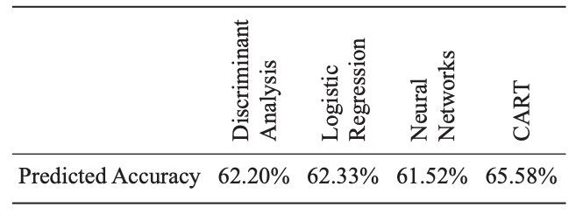

*Illustration 3. Comparison of credit scoring models by Ince & Aktan (2009)*

Over the years, financial institutions have been improving their scoring methods, raising the accuracy of predictions, however variations of Decision Tree (DT) remain the best options. According to Abellán (2017), DT has a simple structure that can be used as a classifier. Elements for the algorithm should be described by one or more attribute variables (features), and by a single class variable to predict the result. In simple words, the features contain data on the previous credit report of the customers, if they currently pay for other loans, if they have got a job with an acceptable salary, if they are married and other details. The class value provides information on the short answer – to give loan to the customer or not. ML-driven underwriting in the banking sector helps banks make processes smarter and faster, which is crucial for the “OK Bank” plan to double the numbers of clients. The potential problem in this and related areas is that the customers reluctantly entrust their information or money in AI-driven systems, despite bank’s strong inclining to FinTech (Belanche, 2019). To minimise the trust issues, special attention must be given to privacy and data protection.

**Conclusion**

Unfortunately, the 1500-word limit does not let us write more about risks of AI in banking, such as features in development in rural areas. Also, we did not describe other fascinating implementations, e.g., AI in Auditing Solutions, Debt Collection service, Robo-Advisers, HR, Promotion, and others. Nonetheless we focused on a few main reasons why AI technologies are strongly recommended for present-day banking business models.

**References:**

Wen, P.X. & Dong, L. (2013) Quality model for evaluating SaaS service. *2013 Fourth international conference on emerging intelligent data and web technologies* (pp. 83-87). IEEE.

Digalaki, E. (2022) The impact of artificial intelligence in the banking sector & how AI is being used in 2022. Available from: https://www.businessinsider.com/ai-in-banking-report [Accessed 5 May 2022]

Salmanov, O. (November 21, 2018) The robots are here. *Vedomosti.*

Liu, S. (2020) Artificial Intelligence spending by industry group worldwide 2020. Available from: https://www.statista.com/statistics/940783/ai-spending-by-industry-group/ [Accessed 5 May 2022]

Crosman, P. (2018) How Artificial Intelligence is reshaping jobs in banking. *American Banker*, 183(88), p.1.

Khavya, K. (2018) Banking Bot. *International Journal of New Technology and Research*, 4(7), p.263023.

Schwartz, E. H. (2021) Bank of America’s Virtual Assistant Erica Explodes in Popularity. *Voicebot.ai*. Available from: https://voicebot.ai/2021/04/21/bank-of-americas-virtual-assistant-erica-explodes-in-popularity/ [Accessed 6 May 2022]

Przegalinska, A., Ciechanowski, L., Stroz, A., Gloor, P. & Mazurek, G. (2019) In bot we trust: A new methodology of chatbot performance measures. *Business Horizons*, 62(6), pp.785-797.

Levchenko, V., Boyko, A., Bozhenko, V. & Mynenko, S. (2019) Money laundering risk in developing and transitive economies: Analysis of cyclic component of time series. *Verslas: Teorija ir praktika/Business: Theory and Practice*, 20, pp.492-508.

Kaya, O., Schildbach, J., AG, D.B. & Schneider, S. (2019) Artificial intelligence in banking.*Artificial intelligence.*

Melnikov, A. (2020) ML-Antifraud for online payments. *Open Data Science.* A video lecture available from: https://ods.ai/tracks/antifraud-df2020 [Accessed 7 May 2022]

Ince, H. & Aktan, B. (2009) A comparison of data mining techniques for credit scoring in banking: A managerial perspective. *Journal of Business Economics and Management*, 10(3), pp.233-240.

Abellán, J. and Castellano, J.G. (2017) A comparative study on base classifiers in ensemble methods for credit scoring. *Expert systems with applications*, 73, pp.1-10.

Belanche, D., Casaló, L.V. & Flavián, C. (2019) Artificial Intelligence in FinTech: understanding robo-advisors adoption among customers. *Industrial Management & Data Systems.*<https://www.bettercloud.com/demo-request/>